HALAL MANUAL Date: Jan 2020

Revision 01
BIN ABLAN FOODS INDUSTRY
Ref: HAS/MAN/VC-
P. O. BOX: 35602, DUBAI, U.A.E
06-2020

HALAL POLICY
BIN ABLAN FOODS INDUSTRY is committed to providing first class through setting
quality objectives and targets in all areas of our operation including food delivery with respect
to halal and food safety with the aim of continually improving our service performance. Our
performance is regularly monitored and measured and the results, used by management to
deliver improved customer services.

Consistent with our approach to achieving sustainable outcomes, we are committed to
complying with and exceeding, where practicable, relevant UAE halal and food safety
legislation like ike: UAE.S 2055-1, MS 1500:2019. nd other related requirements as set by ESMA.

BIN ABLAN FOODS INDUSTRY is committed to complying with the requirements
of our halal assurance, food safety and quality management system and to working with our
customers, suppliers, contractors and employees to continually improve its effectiveness.

BIN ABLAN FOODS INDUSTRY is committed to meet the halal regulatory
requirements by ensuring that the ingredients that we use are certified by the authorized halal
certification bodies and other related regulatory bodies, and that our processing aids, equipment
and utensils are clean and free of non-halal ingredients. A Halal committee, comprising
representatives from various departments, has been established with responsibility for all
matters pertaining to halal regularities.

BIN ABLAN FOODS INDUSTRY will work to ensure our quality policy is
communicated maintained and distributed to our customers, suppliers, contractors and
employees and is subject to periodic review to ensure its continued suitability.

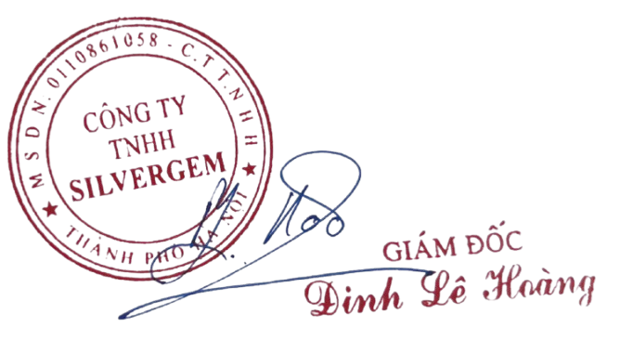

Mohsen Al Mazrouei
Owner
BIN ABLAN FOODS INDUSTRY

Controlled Documents. All rights reserved. No part of this document may be reproduced or transmitted in any form or by any means,
electronic, mechanical, photocopying, recording, or otherwise, without prior written permission of Bin Ablan Foods Industry.

